Narrogin Senior High School

Mathematics Department

Mathematics Applications Year 11

Test 2 ~ Financial Considerations and Matrices

Name ___________________________________________ Total Mark ________________

62

SCSA Objectives in this test may include:

1.1.6 use currency exchange rates to determine the cost in Australian dollars of purchasing a given amount of foreign currency, or the value of a given amount of foreign currency, when converted to Australian dollars.

1.1.7 calculate the dividend paid on a portfolio of shares given the percentage dividend or dividend paid for each share, and compare share values by calculating a price-to-earnings ratio.

1.2.4 use matrices for storing and displaying information that can be presented in rows and columns; for example, databases, links in social or road networks

1.2.5 recognise different types of matrices (row, column, square) and determine their size

1.2.5 recognise different types of matrices ( zero, identity) and determine their size

1.2.6 perform matrix addition, subtraction, multiplication by a scalar, and matrix multiplication, including determining the power of a matrix using technology with matrix arithmetic capabilities when appropriate

1.2.7 use matrices, including matrix products and powers of matrices, to model and solve problems; for example, costing or pricing problems, squaring a matrix to determine the number of ways pairs of people in a communication network can communicate with each other via a third person

**____________________________________________________________________________**

**PART A – CALCULATOR FREE** Part A Mark ____________

24

Instructions: ● Show all working in order for full marks to be awarded

● Round answers to 2 decimal places unless otherwise stated

● NO calculators are permitted in this section

● SCSA Formula Sheet is permitted

1. State the order of each matrix below. [2:1,1]

a) 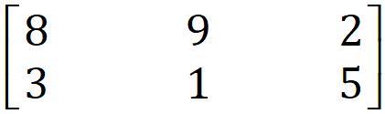 b) 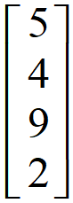

Order _____________________ Order _____________________

2. What is the order of the product matrix CD if C =  and D = ? [1]

Order _____________________

3. What type of matrix has the same number of rows and columns? [1]

________________________________

4. To determine the new balance of an account after an increase of 3%, what number is the

original balance multiplied by? [1]

5. To determine the value of a car after it has been depreciated (lowered in value) by 8%,

what number is the original value multiplied by? [1]

6. Which situation below has the greatest discount (ie the most money)? Justify your answer. [4]

A 50% discount on goods normally priced at $500.

B 40% discount on goods normally priced at $600.

C 80% discount on goods normally priced at $300.

7. State whether or not each of the following is possible, using the matrices below.

Give reasons to justify your answers. [6:2,2,2]

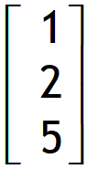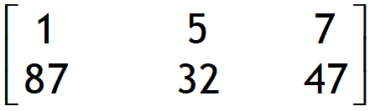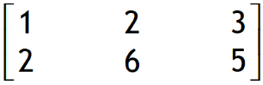

A = B = C =

a) AB Possible? ___________ Reason _____________________________________

b) AC Possible? ___________ Reason _____________________________________

f) A + B Possible? ___________ Reason _____________________________________

8. Show below a: [2:1,1]

a) 2 x 2 identity matrix b) 3 x 3 identity matrix

9. Perform the stated calculations with the given matrices. [4:2,2]

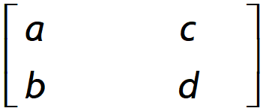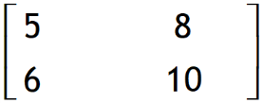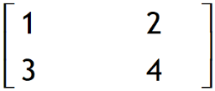

A = B = C =

a) AB b) CB

10. Given that Matrix Y has dimensions 3 by 5 and Matrix Z has dimensions 5 by 7: [2:1,1]

a) State the dimensions of the product YZ.

b) What can you say about the product ZY?

**~ END OF TEST PART A ~**

Narrogin Senior High School

Mathematics Department

Mathematics Applications Year 11

Test 2 ~ Financial Considerations and Matrices

**PART B – CALCULATOR ALLOWED** Part B Mark ____________

38

Instructions: ● Show all working in order for full marks to be awarded

● Round answers to 2 decimal places unless otherwise stated

● Classpads and scientific calculators are permitted

● One double sided A4 page of notes and the SCSA Formula Sheet are permitted

8. A toy company has factories in Aytown, Beetown and Ceetown, all of which manufacture one   
 particular type of doll and one particular type of robot. The matrix A below gives the   
 production costs (in dollars) for Aytown. [6:2,2,2]

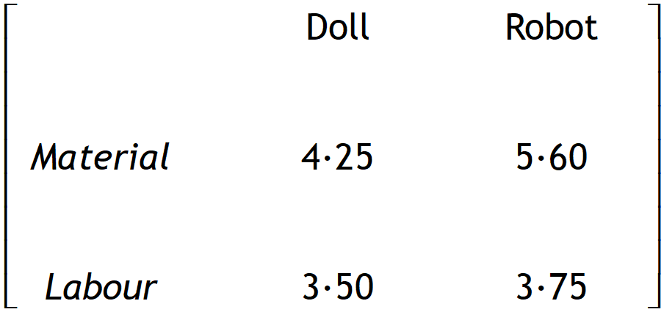

A =

In Beetown material costs are $4∙50 per doll and $5∙70 per robot, whist labour costs are $3∙27   
 per doll and $3∙65 per robot. In Ceeetown a doll has costs of $4∙30 and $3∙40 for materials   
 and labour respectively, whilst a robot has costs of $5∙74 and $3∙70 for materials and labour   
 respectively.

a) Write down the production cost matrices for Beetown and Ceetown.

b) Assuming each plant makes the same number of dolls and robots, write down the matrix   
 representing the average production costs for the three factories.

c) Suppose that labour costs are increased by 10% in Aytown, resulting in a new production   
 cost matrix Aʹ for Aytown. Find the matrix Aʹ.

9. The brokerage fees charged by a stockbroker are: [2]

|  |  |  |
| --- | --- | --- |
| Share value | Up to $15000 | $15000 and over |
| Brokerage | $69∙95 | 0∙60% of the trade value |

Determine the brokerage fee for 2000 shares @ $7∙60 per share.

10. Jason is paid an annual salary of $68500. Determine Jason’s income per: [3:1,1,1]

a) week b) fortnight c) month

11. The table below shows the conversion rates for a number of international currencies. These  
 were current as at March 16th, 2018. [5:1,2,2]

|  |  |  |  |  |  |  |  |  |  |  |  |  |  |  |  |  |  |
| --- | --- | --- | --- | --- | --- | --- | --- | --- | --- | --- | --- | --- | --- | --- | --- | --- | --- |
|  | | [USD](http://www.xe.com/currency/?currency=USD) | | [EUR](http://www.xe.com/currency/?currency=EUR) | | [GBP](http://www.xe.com/currency/?currency=GBP) | | [INR](http://www.xe.com/currency/?currency=INR) | | [MYR](http://www.xe.com/currency/?currency=MYR) | | [NZD](http://www.xe.com/currency/?currency=NZD) | | [THB](http://www.xe.com/currency/?currency=THB) | | [SGD](http://www.xe.com/currency/?currency=SGD) | [JPY](http://www.xe.com/currency/?currency=JPY) |
|  | 1 [AUD](http://www.xe.com/currency/?currency=AUD) | | [0.77876](http://www.xe.com/currencycharts/?from=AUD&to=USD) | | [0.63276](http://www.xe.com/currencycharts/?from=AUD&to=EUR) | | [0.55907](http://www.xe.com/currencycharts/?from=AUD&to=GBP) | | [50.6021](http://www.xe.com/currencycharts/?from=AUD&to=INR) | | [3.05661](http://www.xe.com/currencycharts/?from=AUD&to=MYR) | | [1.07345](http://www.xe.com/currencycharts/?from=AUD&to=NZD) | | [24.3049](http://www.xe.com/currencycharts/?from=AUD&to=THB) | [1.02400](http://www.xe.com/currencycharts/?from=AUD&to=SGD) | [82.5292](http://www.xe.com/currencycharts/?from=AUD&to=JPY) |

Use this information to answer the following questions.

a) 1 Australian dollar is equivalent to how many New Zealand dollars?

b) Andrew wishes to purchase Euros for his trip overseas.

How many Euros will he be able to purchase for 3000 Australian dollars?

c) After returning from an overseas holiday, Emma still has 2500 Japanese yen.

How much will this convert to when Emma trades her yen for Australian dollars?

12. The table below shows the Youth Allowance rates for people aged between 16 and 24 who are   
 studying full time. Students are able to earn up to $415 per fortnight with no penalty,  
 however if they earn over $498 per fortnight, their fortnightly allowance is reduced by   
 60 cents in the dollar for every dollar they earn over $498. [3]

|  |  |
| --- | --- |
| **Status** | **Fortnightly payment** |
| Singles less than 18 years living at home | $226∙80 |
| Single less than 18 years not living at home | $414∙40 |
| Single older than 18 years living at home | $272∙80 |
| Single older than 18 years not living at home | $414∙40 |
| Single with children | $542∙90 |

Bradley is a 20 year old single student living away from home who has a part time job that   
 pays him $535 per fortnight. Determine the Youth Allowance that Bradley will be paid.

13. Xanthe purchases 8000 shares in Amity Confectionary at a cost of $7∙25 each. The company  
 pays a dividend of 4∙5% of the share price and a brokerage fee of 3% is paid to the   
 stockbroker. [8:3,2,3]

Determine:

a) the total cost of purchasing the shares (including the brokerage fee)

b) the total dividend paid

c) the total gain if Xanthe sells all 8000 shares at the end of one year @ $9∙05 per share.

14.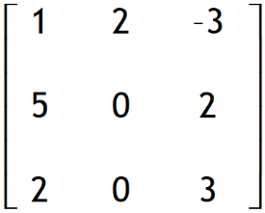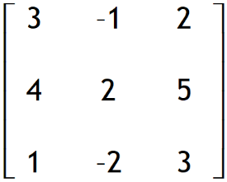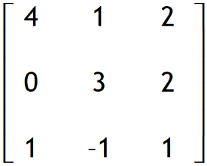

If A = , B = and C = , find:

[5:1,2,2]

a) A – B b) B + (A – C) c) B -2A + 3C

15. Alice worked the following rates and hours. [3]

|  |  |
| --- | --- |
| *Normal rate:* | 35 hours |
| *Time and a half:* | 4 hours |
| *Double time:* | 6 hours |

If Alice earned $1934∙50, determine her normal rate of pay.

16. The Sky High annual production will be held over 3 nights - Friday, Saturday and Sunday.

Ticket prices are $35 for Front Row Adult, $25 for General Seating Adults, $15 for Children   
 and $10 for those with Concession cards. The number of tickets sold for each night is given  
 in the table below. [3]

State 2 matrices and show how matrix multiplication could be used to determine the total   
 value of ticket sales for each of the three nights.

|  |  |  |  |
| --- | --- | --- | --- |
|  | Friday | Saturday | Sunday |
| Front Row  Adult | 25 | 29 | 52 |
| General  Adult | 63 | 82 | 91 |
| Children | 38 | 49 | 67 |
| Concession | 18 | 25 | 39 |

**~ END OF TEST PART B ~**